**Build Python Code**

**Import the libraries**

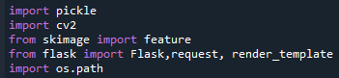

Importing the flask module in the project is mandatory. Flask constructor takes the name of the current module (__name__) as argument.

https://lh3.googleusercontent.com/FU5s86PCCueG7AL4mib2NMN44HfDpJPXki8BkF_v0wgidJ6UN3CsoUJLxf_69JBUOHexgOj21p3LWGOshYMtDwUHJBEQ8VRRV-dPJVenN5DBJuWIXNUUuzxYC_PhlUp9WJV0aeS4

**Render HTML Page:**

https://lh4.googleusercontent.com/L9HrYzhTEEqutNigMZtUKcuuRYov2n0wB2rhYM27S4JIu8aCUz3UIt2uQVZ-u2JttZiqnfXhkd5H4Fz4mXvxKUD0P2rthKgGA8LiHRZK9T55UE3K_OAAF4u6jUZM8-pkQUylbklS

Here, declared constructor is used to route to the HTML page created earlier.

In the above example, ‘/’ URL is bound with about.html function. Hence, when the home page of the web server is opened in browser, the html page is rendered.

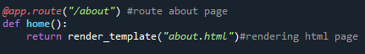

Here, **“about.html”**is rendered when home button is clicked on the UI.

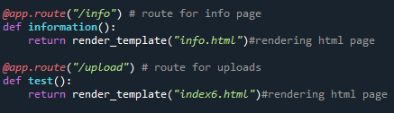

Similarly, **info.html** and **index6.html** are rendered when info and predict buttons are clicked on UI.

Retrieve the Values from UI

Whenever you give the inputs from the html page, the values can be retrieved using POST Method.

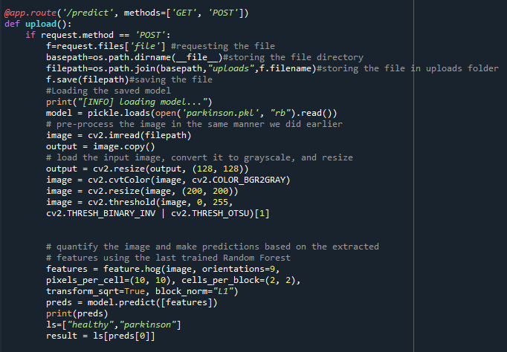

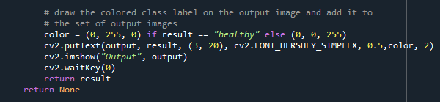

Here we are routing our app to upload() function. This function retrieves all the values from the HTML page using Post request. We are requesting to upload image using the request function.

We take the input from the user, and preprocess the image(convert to gray scale, resize, threshold)).It is necessary to preprocess the data so as give it to the model to predict the output. Once the output is predicted, result is shown on opencv window and html page.

**Main Function:**

https://lh6.googleusercontent.com/T8DsOHEtlYUYYhYEnFYnHMtHJ6glsjJ6kInyZIdGO1V-x--w9myw-4x-AdCAGa4Wt9uUNaTFoeGV-y2bc0GXb9UAz4tVHXqSmwc0e35nDm2wfYh_gWO47efa4Nx9WCxyoTKb2Zcb